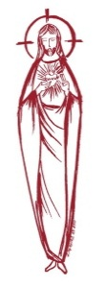**SACRED HEART PARISH**

Sacred Heart Parish Founded 1814, The First Catholic Parish in the STate of New Jersey

Sacred Heart Church, 343 South broad Street, Trenton, New Jersey 08608

Holy Cross Church, 233 Adeline Street, Trenton, New Jersey 08611

**ALL ARE WELCOME**

Whatever your present status in the Catholic Church, whatever your current family or marital situation,

Whatever your past or present religious affiliation, whatever your personal history, age, background, or

race, whatever your own self-image or esteem, you are invited, welcomed, accepted, loved and

respected at the Parish of the Sacred Heart.

**PASTOR**

Rev. Msgr. Dennis A. Apoldite

[frdennis@trentonsacredheart.org](mailto:frdennis@trentonsacredheart.org)

**PAROCHIAL VICAR**

Rev. Charles Muorah

**Felician Residence for Clergy**

233 Adeline Street, Trenton, New Jersey 08611

609-393-4826 ext. 108 for Fr Charles

**DEACON**

Dr. Christian Nnajiofor

**Business Manager / ADMINISTRATIVE ASSISTANT**

John DeSantis: secretary@trentonsacredheart.org

**Administrator of religious education**

Mary Tovar: reled@trentonsacredheart.org

**COORDINATORS OF SACRED MUSIC**

Natalie Megules ~ 609-575-6484

Rupert Peters ~ Gospel Mass 609-442-7871

**MAINTENANCE DEPARTMENT**

Frank Rios

**Trustees**

Jack Breuer and Ellieen Ancrum Ingbritsen,

**OFFICE HOURS**

9:00am – 4:00pm Monday – Friday

**SACRED HEART PARISH OFFICE**

343 South Broad Street, Trenton, NJ 08608

**Phone: (609) 393-2801 ~ Fax: (609) 989-8997**

**WEB PAGE:**

www.trentonsacredheart.org

**CEMETERY RECORDS**

Contact The Office of Catholic Cemeteries at 609-394-2017 or DirectorofCemeteries@DioceseofTrenton.org

**SACRAMENTAL RECORDS**

Sacred Heart Church, Saint John’s Church, Saint Francis Church, Saints Peter and Paul Church, Saint Stanislaus Church, Holy Cross Church, Blessed Sacrament Church, Our Lady of Divine Shepherd Church, Blessed Sacrament/Our Lady of Divine Shepherd Parish and Divine Mercy Parish.

**Liturgy Schedule**

**Sacred Heart**

Monday, Tuesday, Wednesday and Friday

12:10 Noon

Saturday Evening 5:15 PM

Sunday Morning 9:00 and 11:15 AM

**HOLY CROSS**

Monday, Thursday and Friday 8:00 AM

Saturday Evening 4:00 PM

Sunday Morning 10:00 AM Gospel

12:00 Noon Polish

For each Holy Day please reference the bulletin

**SACRAMENTS**

**BAPTISM**

Please call the Parish Office at least one month in advance.

**RECONCILIATION**

Every First Friday following the 12:10PM Mass SHC

Saturday afternoon ~ 4:30 to 5:00 PM SHC

Every Saturday from 3:30 to 3:50 PM HCC

Every Sunday 9:30 to 9:50AM HCC

and by appointment.

**EUCHARISTIC ADORATION**

First Saturday of the Month 2:30 to 3:30 pm

in Holy Cross Church

**MARRIAGE**

Please call the Parish Priest at least one year in advance to set up initial meeting and to confirm a wedding

date and time.

**ANOINTING OF THE SICK**

Please call the Priests any time 609-393-2801.

**COMMUNION TO THE HOMEBOUND**

Call the Parish Office to schedule home visit.

**CONSIDERING PRIESTHOOD?**

Email: [Vocations@DioceseofTrenton.org](mailto:Vocations@DioceseofTrenton.org)



**THE SOLEMNITY OF THE MOST**

**HOLY BODY AND BLOOD OF CHRIST**

**June 11, 2023**

**MASS INTENTIONS**

**Saturday, June 10**

4:00 pm ~ Shelby Rowe and Dolores Krysztofik

5:15 pm SHC ~ Ken and Lucille Fisher

**Sunday, June 11 ~ Corpus Christi**

9:00 SHC ~ Holy Name & Hoch and Ridorfino Families

10:00 ~ The Intentions of the People of the Parish

11:15 SHC ~ Marie Audine Boyer

12:00 HCC Polish ~ Bozena, Antono & Wincenty Plotka

**Monday, June 12**

8:00 am HCC ~ Donald J. and Ruthmarie Manger

12:10pm SHC ~ Pam Yuhas

**Tuesday, June 13**

12:10 pm SHC ~ Gary Furman

**Wednesday, June 14**

12:10 pm SHC ~ Betty DuMont

**Thursday, June 15**

8:00 am HCC ~ Mary and Vladimir Chernichov

**Friday, June 16 ~ The Most Sacred Heart of Jesus**

8:00 am HCC ~ Pauline Lukowicz

12:10pm SHC ~ Arturo Tagliaferri

**Saturday, June 17**

4:00 pm ~ The People of our Parish

5:15 pm SHC ~ Father’s Day Intentions

**Sunday, June 18**

9:00 SHC ~ Father’s Day Intentions

10:00 ~ Father’s Day Intentions

11:15 SHC ~ Father’s Day Intentions

12:00 HCC Polish ~ Father’s Day Intentions

**OUR SICK LIST**

Carole Minotti, Dolores DeBlasio, Ruby Covington, Judith Santigo, Ching Kukis, Dan Breese Jr, Brenna Kennedy-Moore, Dawn Chia, Mark Friedman, Robert Leighton, Patrick Leighton, Alexander A. Ladnyk, Kelly Nitti, Lauren Clayton, Joseph Edralin, Margie Tiongson, Kevin, Vincent Cooper, Jr., Gail Ladnyk, Leo Genovesi, Sloane Donnelly, Richard Buckley, Tony Ragolia, Barbara Burrows, John Matthews, Robert Mahon, Charles Burrows, Dorothy Amoroso, Maryann Sullivan, Regina Friedman, Rita Mich, Stanley Winowicz, Greg Schafer, Jack Hardiman, Paul Leighton, Amy Birk, Julia Grazioli, Matt and Leona Tydryszewski.

**OUR DECEASED**

Irene Murray, Edward Bastecki, Christopher J Kurilla, Comfort Krah, Janet Aulletta, Judy Flaherty, and our friends at South Village, Riverside Nursing and Rehabilitation Center, Mill House and Waters Edge.

**MINISTRY SCHEDULE**

(subject to change)

**Saturday, June 10**

4:00pm HCC ~ Fr Charles L. C Benitez Em. M Herpel

5:15pm SHC ~ Msgr. Dennis L.N Kazior EM.W Lewis & A Solack

**Sunday, June 11 FEAST OF CORPUS CHRISTI**

9:00 SHC ~ Msgr. Dennis L.K Valentino Em K Myers & O Nagbe

10:00 HCC ~ Fr. Charles L O Nnadi EM D Ezeuka

11:15 SHC ~ FR Charles L. J. Rhodes Em K. Myers, E. Wirzburger

12:00 HCC Polish ~ Msgr Dennis

**Saturday, June 17**

4:00pm HCC ~ Fr Charles L. R Micharski Em. C Benitez

5:15pm SHC ~ Msgr. Dennis L. L Bellina EM. M Salamandra & B DuMont

**Sunday, June 18 ~ 11th SUNDAY IN ORDINARY TIME**

9:00 SHC ~ Msgr. Dennis L.E Wengryn Em F & E Zielinski

10:00 HCC ~ Fr. Charles L R Nnajiofor EM Q Hilton

11:15 SHC ~ Msgr. Dennis L. M. Rhodes Em B. Allaire, L. Boyle

12:00 HCC Polish ~ Fr. Marian L.

**WEEKLY COLLECTION**

Last weekend’s collection amounted to $11,185.00 and the Catholic Communication Campaign amounted to

$422.00. This includes the donations received in Church and the mail ins. Thank you for your continued support of our parish.

**2023 ANNUAL CATHOLIC APPEAL UPDATE**

Goal: $33,000.00 : Pledged: $43,486.00 (132% of Goal)

**READINGS FOR THE WEEK**

**Tenth Week of Ordinary Time**

**Sunday** Dt 8:2-3, 14b-16a; 1 Cor 10:16-17; Jn 6:51-58

**Monday** 2 Cor 1:1-7; Mt 5:1-12

**Tuesday** 2 Cor 1:18-22; Mt 5:13-16

**Wednesday** 2 Cor 3:4-11; Mt 5:17-19

**Thursday** 2 Cor 3:15—4:1, 3-6; Mt 5:20-26

**Friday** Dt 7:6-11; 1 Jn 4:7-16; Mt 11:25-30

**Saturday**2 Cor 5:14-21; Lk 2:41-51

**PROMISE TO PROTECT**

The Diocese of Trenton is committed to the norms of the U.S. Bishop’s Charter for the Protection of Children and Young People in regard to the reporting and investigation of sexual abuse allegations involving minors. If you have been sexually abused as a minor by anyone representing the Catholic Church, you can report that abuse through the diocesan Hotline: 1-888-296-2965 or via e-mail at [abuseline@dioceseoftrenton.org](mailto:abuseline@dioceseoftrenton.org). Allegations are reported to the appropriate law enforcement agencies.

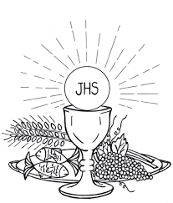

**THE SOLEMNITY OF THE MOST**

**HOLY BODY AND BLOOD OF CHRIST**

The Solemnity of the Most Holy Body and Blood of Christ is also known as the Solemnity of Corpus Christi, which translates from Latin to "Body of Christ." This feast originated in France in the mid thirteenth century and was extended to the whole Church by Pope Urban IV in 1264. This feast is celebrated on the Thursday following the Trinity Sunday or, as in the USA, on the Sunday following that feast.

This feast calls us to focus on two manifestations of the Body of Christ, the Holy Eucharist and the Church. The primary purpose of this feast is to focus our attention on the Eucharist. The opening prayer at Mass calls our attention to Jesus' suffering and death and our worship of Him, especially in the Eucharist.

At every Mass our attention is called to the Eucharist and the Real Presence of Christ in it. The secondary focus of this feast is upon the Body of Christ as it is present in the Church. The Church is called the Body of Christ because of the intimate communion which Jesus shares with his disciples. He expresses this in the gospels by using the metaphor of a body in which He is the head. This image helps keep in focus both the unity and the diversity of the Church.

The Feast of Corpus Christi is commonly used as an opportunity for public Eucharistic processions, which serves as a sign of common faith and adoration. Our worship of Jesus in His Body and Blood calls us to offer to God our Father a pledge of undivided love and an offering of ourselves to the service of others.

**GRADUATION**

We would like to list the names of our parish graduates from high school and college/university and the schools from which they have been graduated in the June 17– 18th bulletin. Will you please forward this information to the parish office by June 12th, so that we, as a parish family can acknowledge our graduates! Thank you.

**YOUR COUNTRY**

We are working on a project to reflect the countries of origin of our parishioners.

Please inform us by June 18th

Place the form in the collection basket or write the country on the back of your weekly envelope.

My Country is: __________________________________

**FATHER’S DAY**

**SPIRITUAL REMEMBERANCE CARDS**

The Father’s day Spiritual Mass cards are available in the vestibule of the Church. Please take as many as you need and return the outside envelope so it can be placed at the altar for the month of June.

**INTERFAITH CAREGIVERS**

Interfaith Caregivers of Greater Mercer County (ICGMC), an interfaith coalition, is dedicated to promoting the independence, dignity and wellness of homebound elderly and people with disabilities by matching them with caring volunteers who assist with the tasks of everyday life. Interfaith Caregivers of Greater Mercer County was established in 1994 with a "Faith in Action" grant from the Robert Wood Johnson Foundation. For over two decades we have worked to improve the quality of life and help meet the concerns and special needs of underserved, homebound elderly and adults with disabilities in Mercer County, New Jersey. Our interdenominational coalition of 30 congregations and over 400 trained volunteers provide support and education that enables care-receivers to remain in their homes. All services and programs are offered free-of-charge without proselytization and without regard to race, religion, ethnicity, national origin, sexual orientation or income.

**RCIA – BECOMING CATHOLIC**

Are you interested in becoming a Catholic? The desire to draw closer to God is in all of us, for we are his creation. Do you know an adult who would like to find out about what we believe? Do you know anyone who has not completed the Sacraments of Communion and Confirmation, and would like to? Please prayerfully consider who might be interested in entering more fully into the Catholic faith and invite them to join us for our “Inquiry session” scheduled to begin in September. Please contact Msgr. Dennis at

[Frdennis@trentonsacredheart.org](mailto:Frdennis@trentonsacredheart.org) or

609-393-2801 ext. 102..

**RELIGIOUS EDUCATION NEWS**

Parents are asked to reregister their children on or before the last class. Re-registration forms are available online or from Mary Tovar. The tuition fee is $65.00 per child.

**NEW REGISTRATIONS ACCEPTED**

Parents who have children beginning their Religious Education are asked to register as soon as possible. You can obtain the form on our web page or by calling the parish office.

**COMMUNION AND CONFIRMATION CLASS**

If you have a child who is ready to make his or her First Communion or Confirmation, the Diocesan guideline requirement is that they complete two years of Religious Education. For First Communion your child must attend First and Second year of Religious Ed and for Confirmation the child must

complete grade 7 and 8 before receiving the Sacrament of Confirmation. Please be sure to register soon.

**ALTAR ROSARY SOCIETY**

Our parish Altar Rosary Society held their elections recently for the Officer who will serve for a two year term. Congratulations to: President Joan Buckley, Vice President Rosita Santiago Peters, Recording Secretary Carmen Benitez, Corresponding Secretary Priscilla Bloking, and Treasurer Patricia McIntyre.

**NEXT WEEKEND IS FOOD COLLECTION**

**FOR THE NEEDY OF OUR NEIGHBORHOOD**  
  
         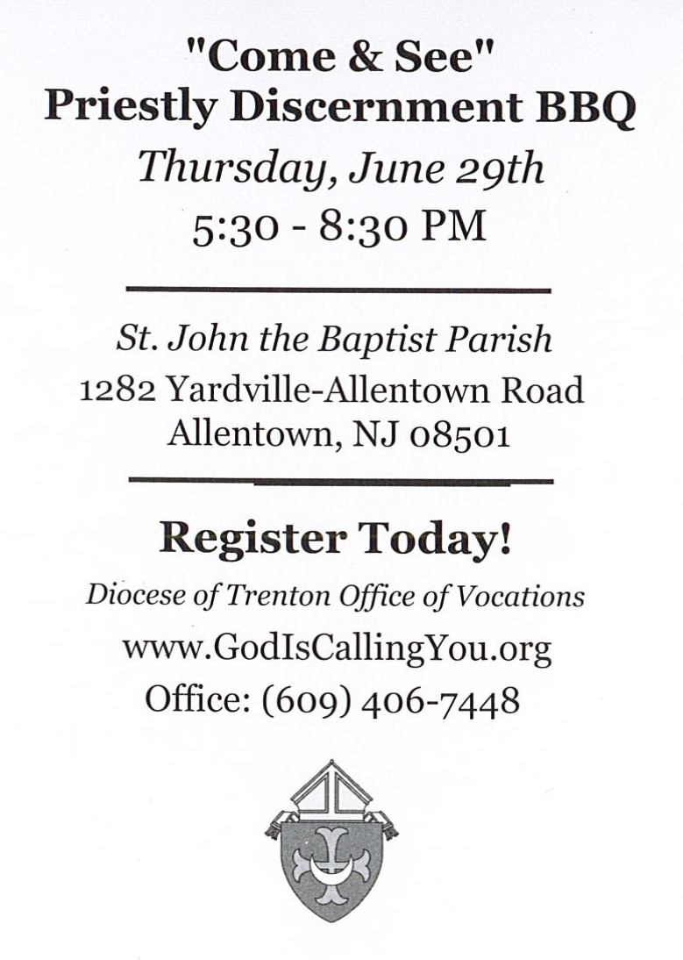

**RETROUVAILLE**

Tens of thousands of couples have healed their marriages through Retrouvaille (pronounced Retro-vy). Couples learn to build communication skills and to increase intimacy. It provides help for marriage problems, difficulties or crises. The Office of Family Life, Diocese of Metuchen, will sponsor a Retrouvaille weekend on August 18-20. For further information, please contact Rich Colasuonno (732-236-0671) or Annette Colasuonno (732-672-0748) or email [3024@helpourmarriage.org](mailto:3024@helpourmarriage.org). The Family Life Center in Malvern, PA will hold Retrouvaille weekends on August 18 - 20 and October 6 – 8. For more information, or to register, visit www.HelpOurMarriage.org or call 215-766-3944 or 800-470-2230. All inquiries are strictly confidential.



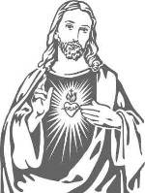

**Solemnity of the Sacred Heart of Jesus**

**Friday, June 16th**

**Please join us in Celebration of our**

**Parish Feast Day**

**at the 12:10 Noon Mass.**

**Pizza will be served following the Mass. In order to be properly prepared, please call the parish office to confirm your attendance by Wednesday, June 14th**



**What is the National Eucharistic Revival?**

**A NATIONAL EUCHARISTIC REVIVAL**

**2022-2025**

We are pleased to announce that our diocese will be participating in a three year-long Eucharistic Revival sponsored by the Bishops of the United States. This initiative seeks to: Provide a more profound encounter with Jesus Christ at Mass and through this powerful encounter, find personal healing and courage to take the Gospel into a world in need of authentic love. To spark personal conversions through a relationship with Christ present in the Eucharist. To elevate the truth and practices of our faith through a rediscovery of the Real Presence of Jesus in the Eucharist. To form, inspire and launch missionary disciples filled with the love of God and neighbor that comes through an encounter with Jesus in the Eucharist. This year we begin phase two: The Year of Parish Revival. More information will follow.

**Sacred Heart Parish Picnic**



At the CYO of Mercer County

453 Yardville-Allentown Road.

Yardville, NJ 08620

July 9, 2023 ~ 1:00-5:00PM

MASS will be Celebrated at 1:15PM

at the Camp Grounds

Our parish will provide

Hot Dogs and Hamburgers, Rolls, Chips, Water and Soft Drinks

Please bring your own side dishes.

This year we ask all who attend to bring a dessert from your country of origin for the sharing table and attach a label to identify your country on the dessert.

All Day Swimming, Games,

Outdoor Recreation, Playground Area

TEAR OFF BOTTOM PORTION AND RETURN

IN THE COLLECTION BASKET OR

SEND TO PARISH OFFICE BEFORE JULY 3rd

~~~~~~~~~~~~~~~~~~~~~~~~~~

Name: __________________________________

__________________________________________

Email address ____________________________

Number attending ___________

